1. Browse to the event hub dashboard, enable “total requests”, and “successful requests”  
   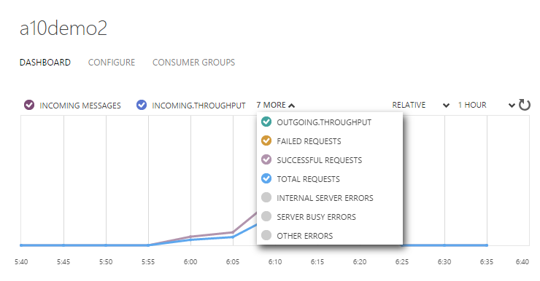
2. Refresh the view, if more than 5 minutes has passed since the data started flowing then the graph should show something.  
   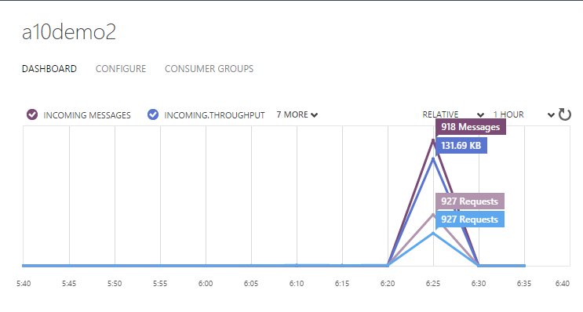
3. Click the create consumer Group button at the bottom  
   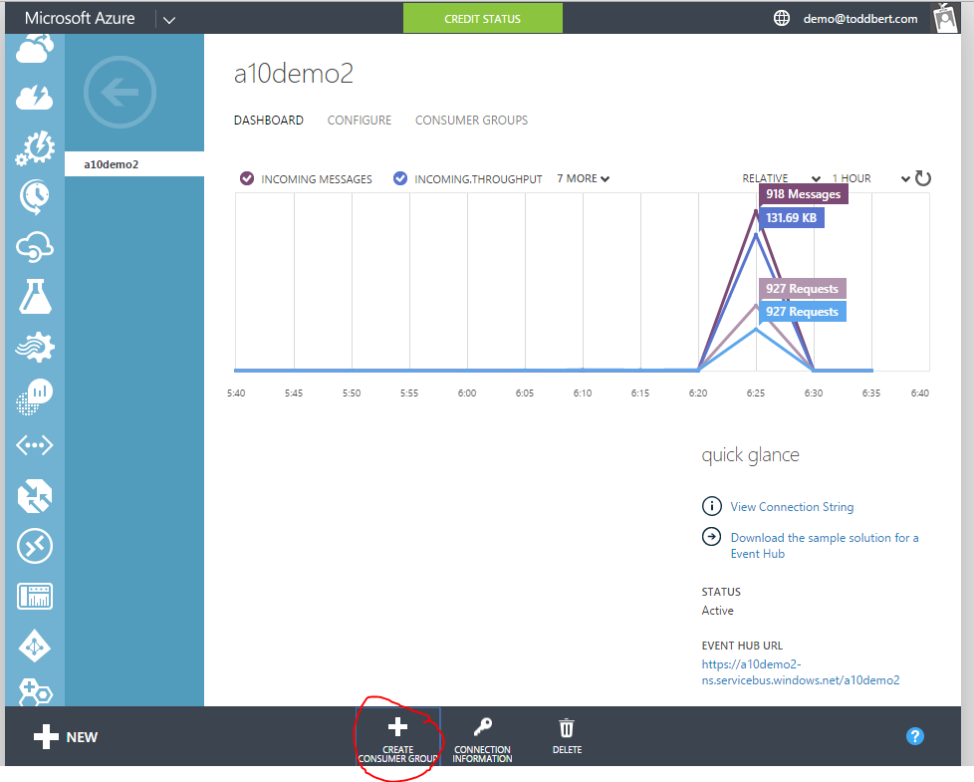
4. Give the consumer group a name 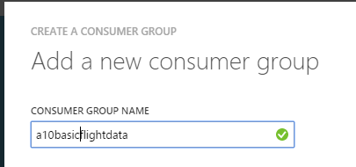
5. Click the “Stream Analytics icon on the left  
   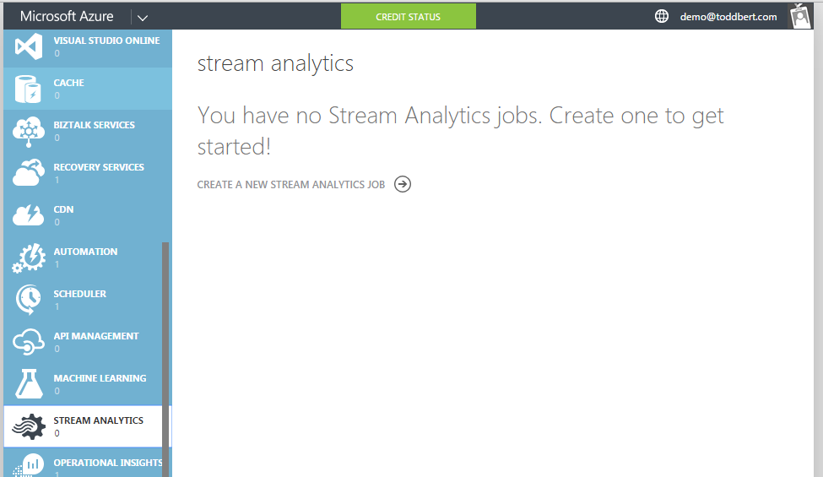
6. Enter the details for the job and set the location to be same as the event hub, creating will take a few minutes. Can flip back to the Event hub to view dashboard whilst you wait.  
   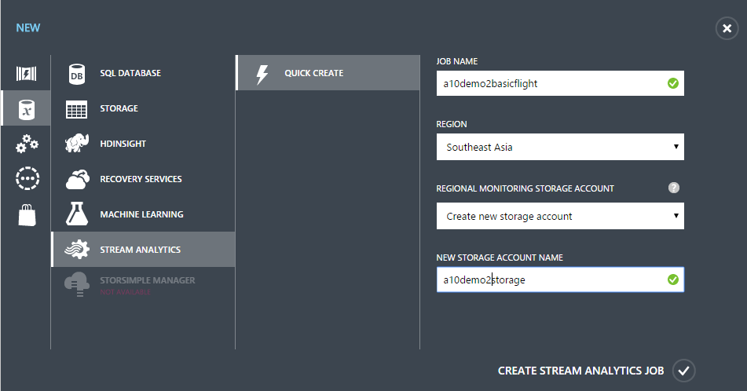
7. Click on the name of the newly created job
8. Click on the Add Input button  
   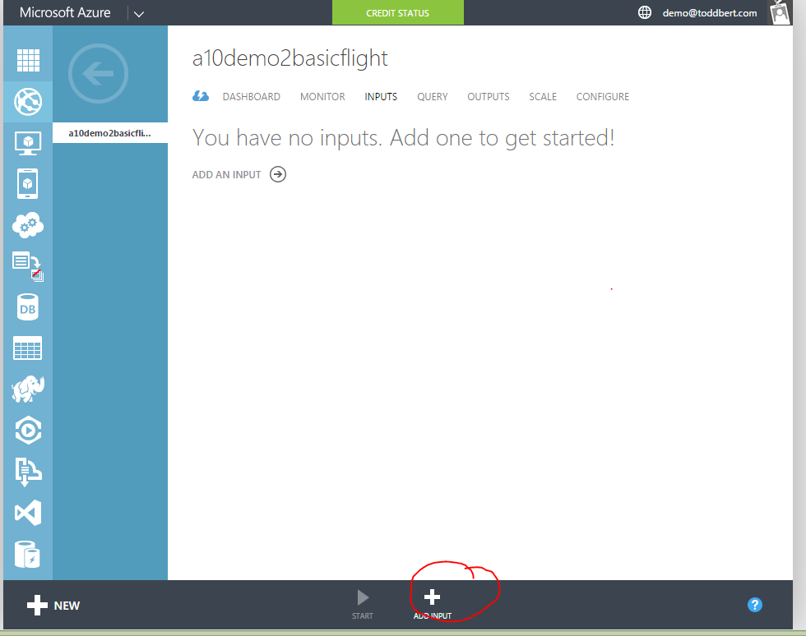
9. Select Data Stream  
   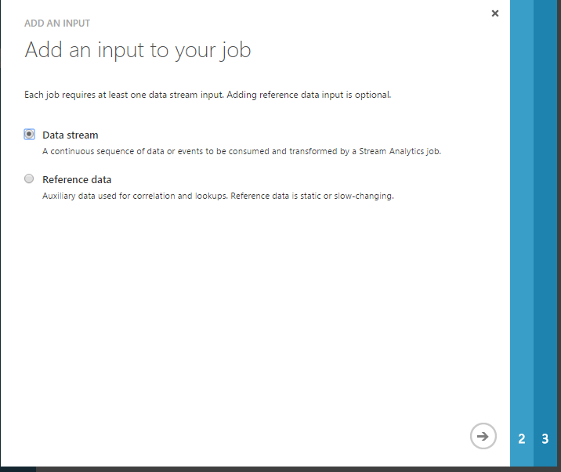
10. Select Event Hub  
    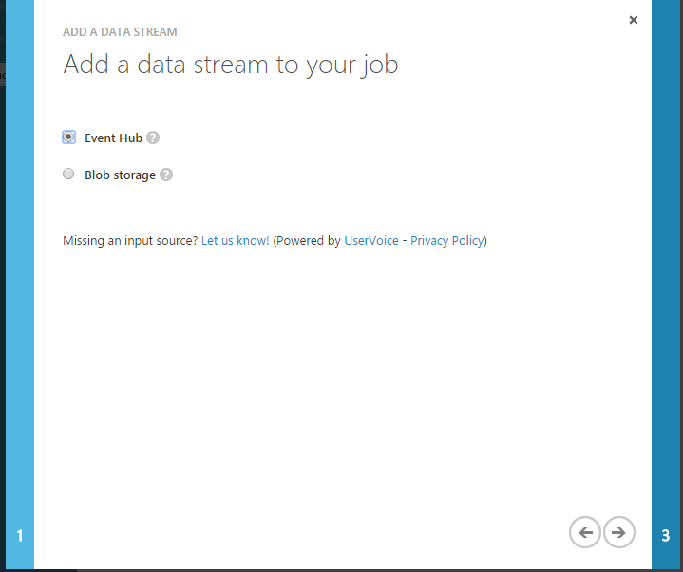
11. Provide an alias and select the other details   
    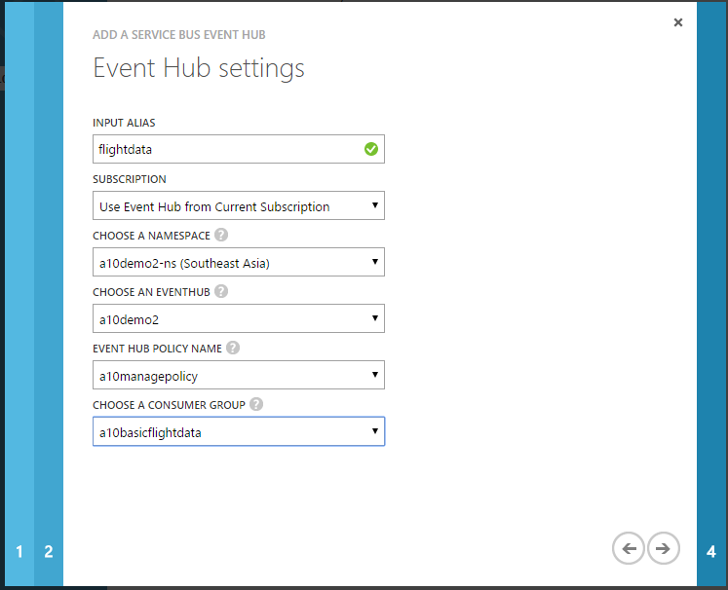
12. Select JSON and UTF-8  
    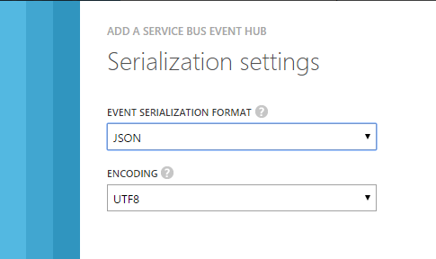
13. Once its created select Sample Data  
    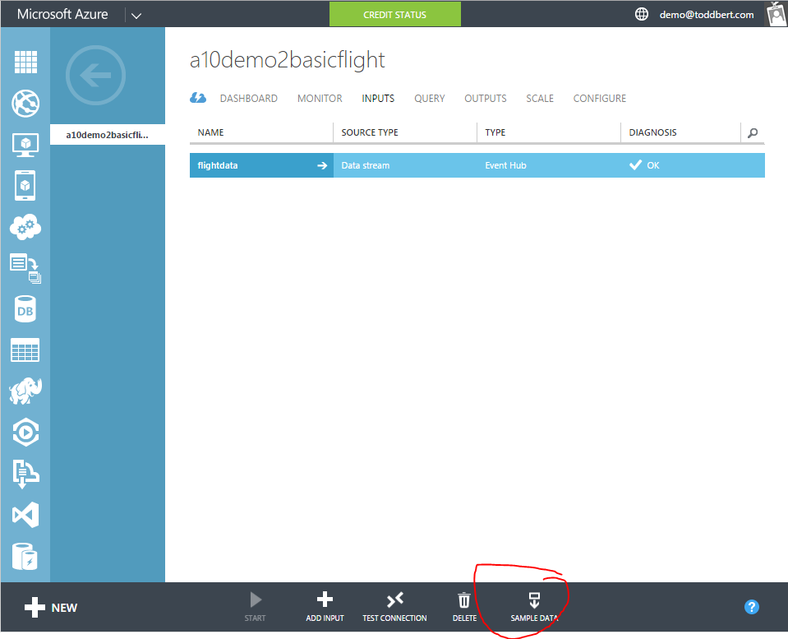
14. Select a start time and duration for the sample (defaults should be fine)  
    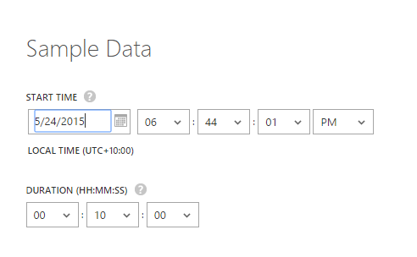
15. Click on the Notification icon to watch the “Sampling data” message.
16. Once completed click the details icon to see a download link to the data file. Download the sample data file.  
    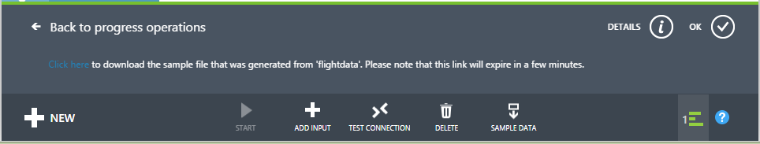
17. Select the Query Tab  
    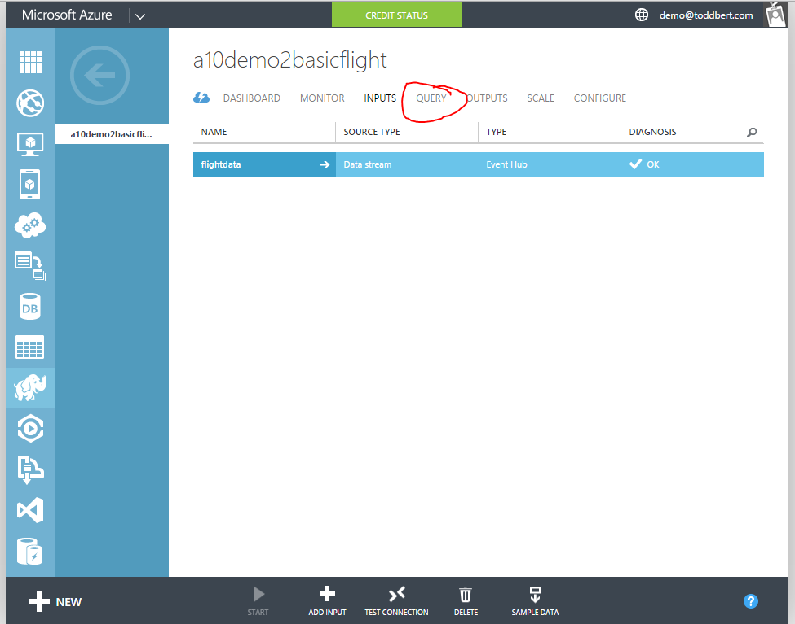
18. Replace the query with SELECT \* FROM flightdata (or your input alias)  
    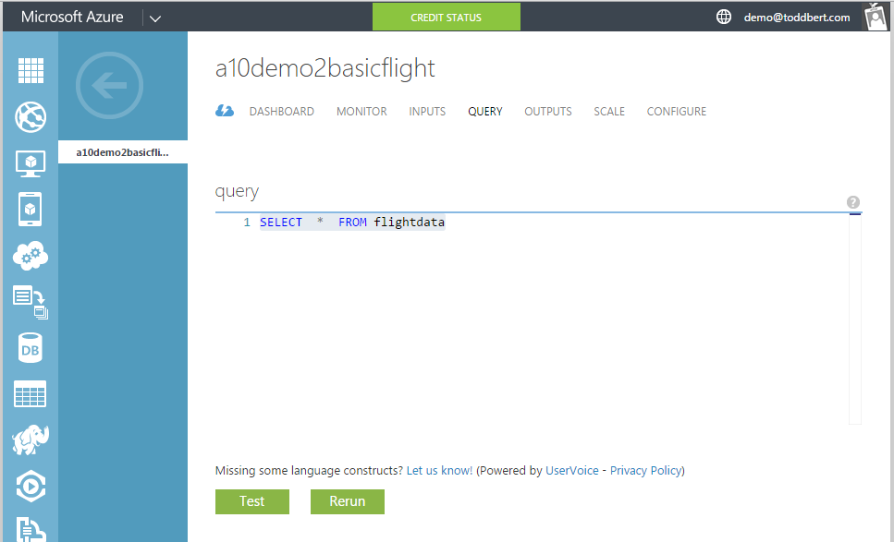
19. Click the Test button and browse to the sample data file you downloaded earlier  
    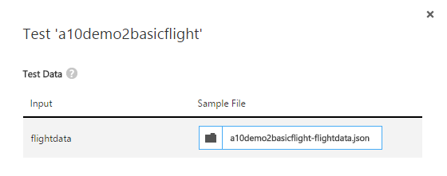
20. Click the “rerun button and scoll down to view results  
    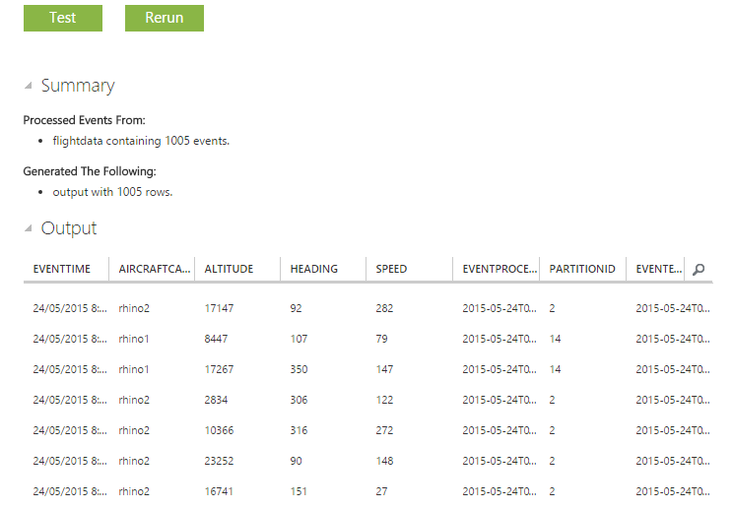
21. Update query to:  
    SELECT AircraftCallsign, Avg(Altitude) as AverageAltitude, Avg(Speed) as AverageSpeed,  
    System.Timestamp AS OutputTime   
    FROM flightdata  
    Group By TumblingWindow(second,5), AircraftCallsign

WITH Vehicles AS (

SELECT objectId, count(objectId) , ObjectTypeName

FROM toddflightdata

WHERE ObjectTypeName <> ""

GROUP BY objectId, ObjectTypeName, TUMBLINGWINDOW(second,10)

)

SELECT ObjectTypeName, COUNT(\*) AS VehicleCount, System.Timestamp AS OutputTime

INTO PowerBILink

FROM Vehicles

GROUP BY TUMBLINGWINDOW(second,9), ObjectTypeName

SELECT ObjectId, CountryId, Type1, Type2, Type3, ObjectTypeName, Max(Altitude) as Altitude, System.Timestamp AS OutputTime

INTO a10flightprofile

FROM toddflightdata

WHERE Type1 = 1 AND ObjectTypeName <> ""

GROUP BY TUMBLINGWINDOW(second,10), ObjectId, CountryId, ObjectTypeName, Type1, Type2, Type3

SELECT ObjectId, CountryId, Type1, Type2, Type3, ObjectTypeName, MAX(Lattitude) As Lattitude, MAX(Longtitude) as Longtitude, System.Timestamp AS OutputTime

INTO EnemyGround

FROM toddflightdata

WHERE CountryId = 0 AND ObjectTypeName <> "" and Type1 = 2

GROUP BY TUMBLINGWINDOW(second,10), ObjectId, CountryId, ObjectTypeName, Type1, Type2, Type3

1. Click Rerun and verify results
2. Click Save button
3. Click the outputs tab
4. Click Add an output
5. Select Power BI  
   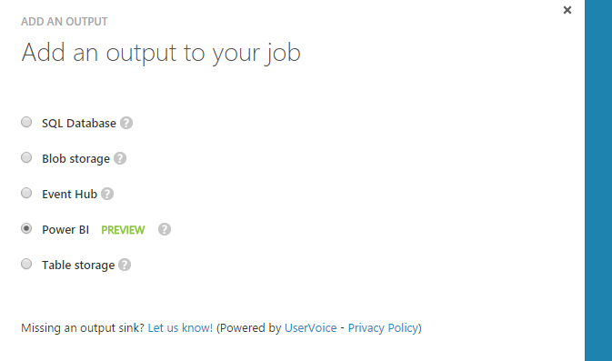
6. Click Authorize Now  
   